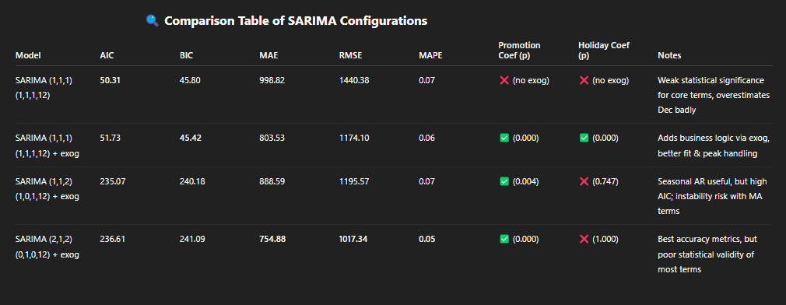
Comparison Table of SARIMA Configurations
Model | AIC | BIC | MAE | RMSE | MAPE | Promotion Coef (p) | Holiday Coef (p) | Notes
SARIMA (1,1,1)(1,1,1,12) | 50.31 | 45.80 | 998.82 | 1440.38 | 0.07 | ❌ (no exog) | ❌ (no exog) | Weak statistical significance for core terms, overestimates Dec badly
SARIMA (1,1,1)(1,1,1,12) + exog | 51.73 | 45.42 | 803.53 | 1174.10 | 0.06 | ✅ (0.000) | ✅ (0.000) | Adds business logic via exog, better fit & peak handling
SARIMA (1,1,2)(1,0,1,12) + exog | 235.07 | 240.18 | 888.59 | 1195.57 | 0.07 | ✅ (0.004) | ❌ (0.747) | Seasonal AR useful, but high AIC; instability risk with MA terms
SARIMA (2,1,2)(0,1,0,12) + exog | 236.61 | 241.09 | 754.88 | 1017.34 | 0.05 | ✅ (0.000) | ❌ (1.000) | Best accuracy metrics, but poor statistical validity of most terms

🧠 Critical Interpretation
- SARIMA without exog performs the worst overall — high MAE, RMSE, and poor seasonal term significance. It clearly misses the December demand spike and lacks business context.
- Adding exogenous variables (Promotion & HolidayMonth) consistently improves performance across all configurations — especially in reducing error during spike months like December.
- SARIMA (1,1,1)(1,1,1,12) + exog has low AIC/BIC and solid coefficient significance, suggesting it’s well-tuned and statistically valid, though not the most accurate.
- SARIMA (2,1,2)(0,1,0,12) + exog delivers the best forecasting accuracy (lowest MAE/RMSE/MAPE), but its coefficients (AR/MA, Holiday) are mostly insignificant, risking overfitting or model instability.
- SARIMA (1,1,2)(1,0,1,12) + exog has a valid seasonal AR component (p=0.000), but very high AIC/BIC implies poor model parsimony — not a good trade-off.
- Promotion consistently improves predictions, shown by its significant p-value (0.000–0.004) across all models. However, HolidayMonth lacks impact, and might be dropped or redefined more effectively (e.g., holiday type or duration).

🚀 Way Forward (Data Science + Real-World Lens)
- Keep SARIMA (1,1,1)(1,1,1,12) + exog as your baseline: good interpretability, valid coefficients, and strong real-world relevance (especially Promotion).
- Use SARIMA (2,1,2)(0,1,0,12) + exog for short-term operational forecasts if accuracy is paramount and explainability is less critical — but monitor for overfitting or instability.
- Consider re-engineering HolidayMonth into a more granular, categorical or binary feature (e.g., national holiday = 1, else = 0).
- SARIMA has shown limitations in modeling nonlinear peaks (e.g., December). You should now experiment with nonlinear models like XGBoost, Random Forest, or LSTM, integrating the same exogenous features.
- Visualize residuals and conduct Ljung-Box test on final residuals to check for autocorrelation — this will validate your model's adequacy statistically.
- In real-world terms, forecasting holiday spikes requires domain-specific signal engineering, like event calendars, marketing intensity, or competitor behavior — purely statistical models are not enough.

